

Project Name: E-College Portal

Branch DAC Feb-2025

Documentation On

**“E-COLLEGE PORTAL”**

DAC FEB 2025

**Guided By: Bakul Joshi**

Submitted By :

**Group No: 15**

* **Deshpande Sushant Vishwas 250243020023**
* **Lavange Onkar Shivaji 250243020049**
* **Rajkumar Prajapati 250243020073**
* **Nupur Vishnu Siddam 250243020094**

**Table of Contents**

1. Introduction 5
   1. Document Purpose **5**
   2. Project Background **5**
   3. Aim & Objectives **5**
2. Business Requirements Overview 6
3. Functional Requirements 6
   1. Student Module **6**
   2. Staff Module **7**
   3. Admin Module **7**
4. Non-Functional Requirement 7
5. Use Case Diagram 8
   1. Student **8**
   2. Staff **9**
   3. Admin 10
6. Project Architecture Diagram 11
7. Database Design 12
   1. Role **12**
   2. User **12**
   3. Student **13**
   4. Staff 13
   5. City **13**
   6. Course **14**
   7. Course Enrollment **14**
   8. Course Material **14**
   9. Event **15**
   10. Event Registration **15**
   11. Placement Data 15
   12. Placement Application 16
   13. Announcement **16**
   14. Feedback **16**
8. E-R Diagram 17
9. Snapshots 18
10. Conclusion and Future scope 29

**List of Figures**

## Use Case Diagrams 17

Fig 1 Project Architecture ………………………………………………………………….. Fig 2 Student 8

Fig 3 Staff 9

Fig 4 Admin 10

Fig 5 ER Diagram 14

# Introduction:

## Document Purpose:

This document communicates the business requirements and scope for developing E-College Portal. The scope of this document is to define the functional and non functional requirements, business rules and other constraints requirements.

## Project Background:

Colleges and universities manage vast amounts of academic and administrative information daily, ranging from student admissions and course registrations to event coordination and feedback collection. In many institutions, these processes are still handled through manual paperwork or isolated digital tools, leading to inefficiencies, communication gaps, and limited accessibility for students, staff, and administrators.

The E-College Portal is designed as a centralized, web-based platform that integrates all essential academic and administrative functions into one cohesive system. Students can manage their accounts, register for courses and events, apply for internships, and access study materials seamlessly. Staff members can update course content, manage student profiles, and make announcements efficiently. Administrators can oversee user accounts, academic programs, and feedback to ensure smooth institutional operations.

The E-College Portal is designed to digitize and streamline key academic and administrative processes for students, staff, and administrators. By replacing manual tasks with an integrated online platform, it enables faster, more accurate, and more convenient access to services, improving overall efficiency and user experience.

## Aim & Objectives:

The main objective of this project is to build a web-based platform that enhances accessibility and flexibility for students, staff, and administrators. Students will be able to create accounts, access academic resources, register for courses and events, apply for internships, and track their applications. Staff can manage course materials, announcements, and student records, while administrators can oversee user accounts, course catalogs, academic programs, and feedback. The system aims to provide a centralized, user-friendly solution that improves efficiency, communication, and overall academic experience.

# Business Requirements Overview:

* E-College Portal is a public web application accessible to students, staff, and administrators.
* The system is intended for use by educational institutions, starting with a specific college and later extendable to multiple institutions.
* There are three main types of users: Students, Staff, and Administrators.
* Students can register, log in, access academic resources, register for skill development courses and events, apply for internships/placements, and track their applications.
* Staff can manage student profiles, upload and manage course materials, and post announcements.
* Administrators can manage user accounts, course catalogs, academic departments/programs, and review student feedback.
* The E-College Portal provides a centralized platform that connects students, staff, and administrators for efficient academic and administrative operations.
* The system will be maintained by the Administrator.

# Functional Requirements Overview:

Paperless School Management System consists of three modules described as below.

1. Student Module
2. Staff Module
3. Admin Module

# Student Module

# 

* Students can view a personalized dashboard with quick access to relevant information (e.g., course details, timetable, event details).
* Students can browse available skill development courses and register for them online.
* Students can access enrolled courses and download course materials (lecture notes, assignments, syllabi) uploaded by faculty.
* Students can update their personal profile information.
* Students can view their personalized class timetable.
* Students can register for upcoming events.
* Students can apply for internships and placement opportunities, and upload their resumes.
* Students can track their placement status (Applied, Selected, Rejected).
* Students can provide feedback on courses, faculty, and events.

# Staff Module

* Faculty can view a personalized dashboard with an overview of their assigned courses.
* Faculty can view student lists for each of their courses and access individual student profiles.
* Faculty can upload and manage course materials (e.g., lecture slides, assignments, external links) for their students.
* Faculty can update their personal and professional profile information.
* Faculty can post announcements.

# Admin Module

* Administrators can manage all user accounts (add, edit, delete students, faculty, and other admin users) and assign or modify user roles.
* Administrators can manage the entire course catalog (add new courses, edit existing course details, retire courses, assign faculty to courses).
* Administrators can manage academic departments and programs (add, edit, delete departments, assign heads of departments).

# Non-Functional Requirement:

* + The portal should have a professional design, with a clean layout, consistent look and feel, and a visually appealing color scheme suitable for educational purposes.
  + The application should be accessible to all users via the Internet without restrictions on location or device type.
  + As a public-facing platform, it should be capable of handling a sufficient number of concurrent users during the initial launch phase, with scalability for future growth.
  + The system must follow standard usability guidelines for menus, navigation, colors, links, and interactive elements to ensure a user-friendly experience.
  + The portal should be designed for efficiency, enabling users to complete tasks with minimal steps and effort.

# Use-Case Diagram

## Student:

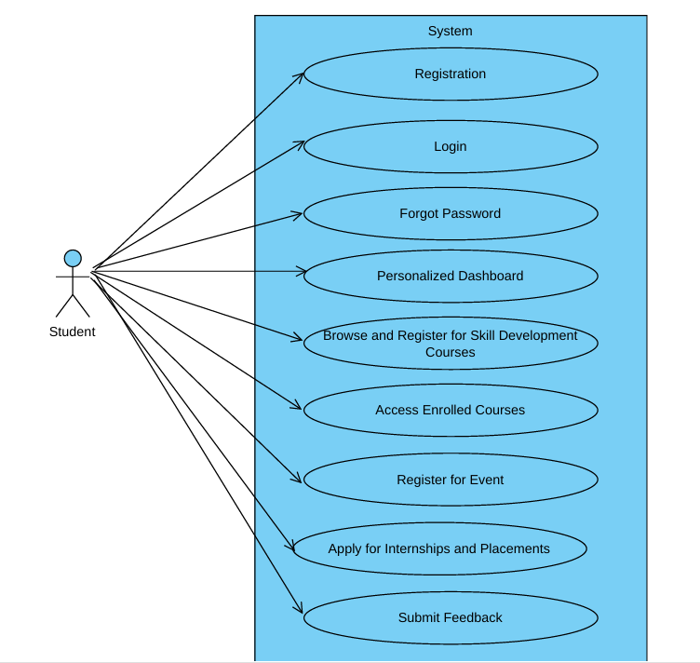

Fig. Use-Case Diagram for Student

## Staff:

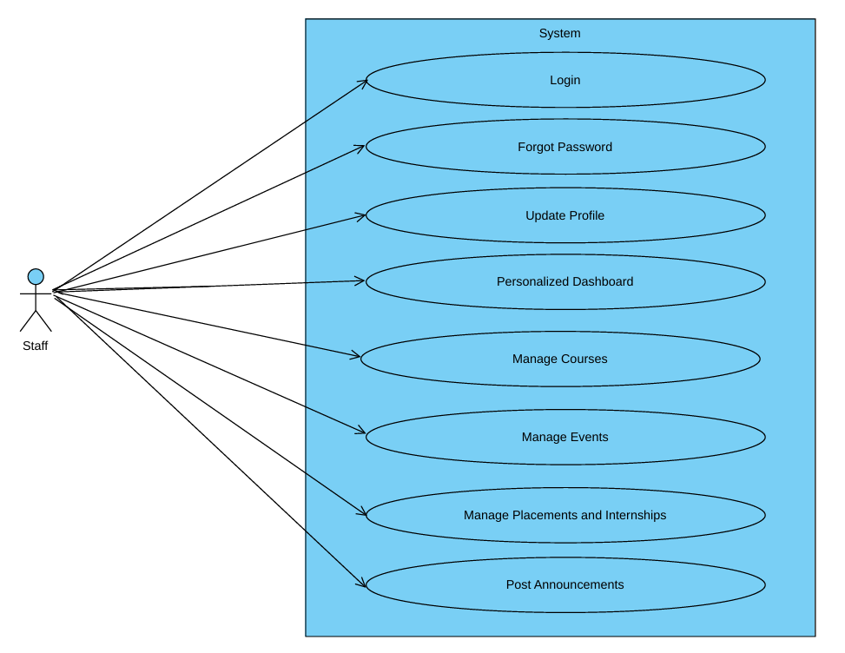

Fig. Use-Case Diagram for Staff

* + **Admin :**

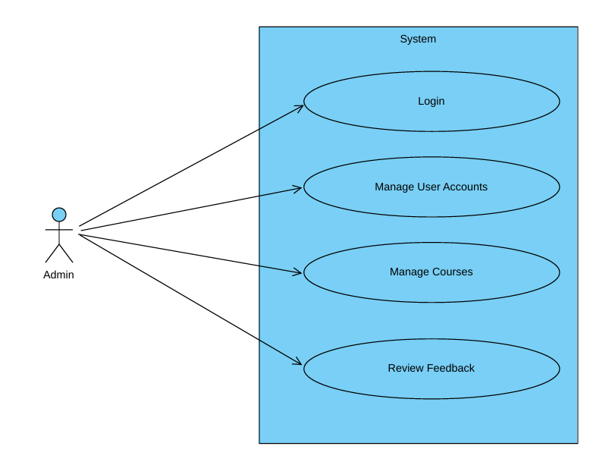

Fig. Use-Case Diagram for Admin

# Project Architecture Diagram:

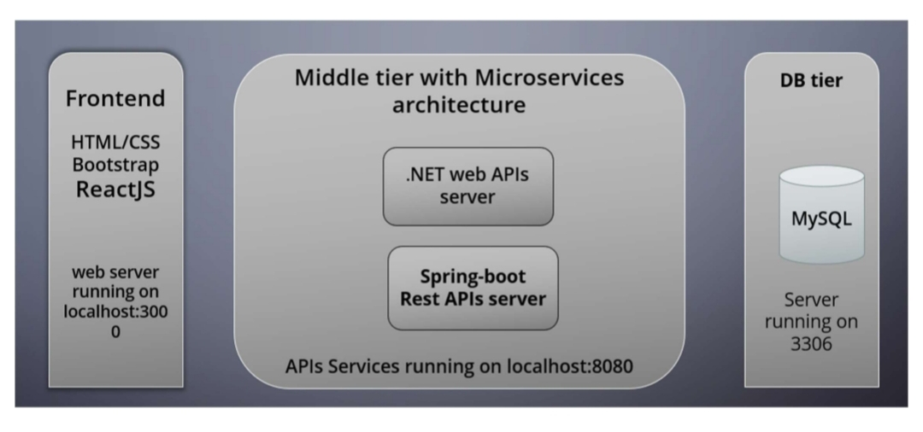

Fig. Project Architecture Diagram

# Database Design:

1. **​Role:**

|  |  |  |  |  |  |
| --- | --- | --- | --- | --- | --- |
| **Field** | **Type** | **Null** | **Key** | **Default** | **Description** |
| rid | INT | NO | Primary Key | auto_increment | Role ID |
| rname | VARCHAR(255) | NO |  | NULL | Role name |

1. **​User:**

|  |  |  |  |  |  |
| --- | --- | --- | --- | --- | --- |
| **Field** | **Type** | **Null** | **Key** | **Default** | **Description** |
| uid | INT | NO | Primary Key | auto_increment | User ID |
| uname | VARCHAR(50) | NO |  | NULL | Username |
| email | VARCHAR(50) | NO |  | NULL | Email address |
| phone_no | VARCHAR(20) | NO |  | NULL | Phone number |
| password | VARCHAR(255) | NO |  | NULL | User password |
| rid | INT | NO | Foreign Key | NULL | Role ID (references Role) |

1. **Student:**

|  |  |  |  |  |  |
| --- | --- | --- | --- | --- | --- |
| **Field** | **Type** | **Null** | **Key** | **Default** | **Description** |
| sid | VARCHAR(20) | NO | Primary Key | NULL | Student ID |
| uid | INT | NO | Foreign Key | NULL | User ID (references User) |
| first_name | VARCHAR(50) | NO |  | NULL | First name |
| last_name | VARCHAR(20) | NO |  | NULL | Last name |
| address_line1 | VARCHAR(20) | NO |  | NULL | Address line 1 |
| address_line2 | VARCHAR(200) | NO |  | NULL | Address line 2 |
| city_id | INT | NO | Foreign Key | NULL | City ID (references City) |

1. **Staff:**

|  |  |  |  |  |  |
| --- | --- | --- | --- | --- | --- |
| **Field** | **Type** | **Null** | **Key** | **Default** | **Description** |
| staff_id | INT | NO | Primary Key | auto_increment | Staff ID |
| uid | INT | NO | Foreign Key | NULL | User ID (references User) |
| first_name | VARCHAR(50) | NO |  | NULL | First name |
| last_name | VARCHAR(50) | NO |  | NULL | Last name |
| address_line1 | VARCHAR(50) | YES |  | NULL | Address line 1 |
| address_line2 | VARCHAR(200) | YES |  | NULL | Address line 2 |
| designation | VARCHAR(200) | YES |  | NULL | Designation |
| city_id | INT | NO | Foreign Key | NULL | City ID (references City) |

1. **City**

|  |  |  |  |  |  |
| --- | --- | --- | --- | --- | --- |
| **Field** | **Type** | **Null** | **Key** | **Default** | **Description** |
| city_id | INT | NO | Primary Key | autoincrement | City ID |
| city_name | VARCHAR(50) | NO |  | NULL | City name |
| state_name | VARCHAR(50) | NO |  | NULL | State name |

1. **Course table:**

|  |  |  |  |  |  |
| --- | --- | --- | --- | --- | --- |
| **Field** | **Type** | **Null** | **Key** | **Default** | **Description** |
| course_id | INT | NO | Primary Key | NULL | Course ID |
| course_name | VARCHAR(255) | NO |  | NULL | Name of the course |
| description | TEXT | NO |  | NULL | Detailed course description |
| start_date | DATETIME | NO |  | NULL | Course start date |
| end_date | DATETIME | NO |  | NULL | Course end date |

1. **Course Enrollment table:**

|  |  |  |  |  |  |
| --- | --- | --- | --- | --- | --- |
| **Field** | **Type** | **Null** | **Key** | **Default** | **Description** |
| enroll_id | INT | NO | Primary Key | NULL | Enrollment ID |
| course_id | INT | NO | Foreign Key | NULL | Foreign Key referencing Course |
| sid | VARCHAR(20) | NO | Foreign Key | NULL | Foreign Key referencing Student |
| start_date | DATETIME | NO |  | NULL | Enrollment start date |
| end_date | DATETIME | NO |  | NULL | Enrollment end date |
| target | VARCHAR(20) | NO |  | NULL | Target category or audience |

1. **Course Material table:**

|  |  |  |  |  |  |
| --- | --- | --- | --- | --- | --- |
| **Field** | **Type** | **Null** | **Key** | **Default** | **Description** |
| material_id | INT | NO | Primary Key | NULL | Material ID |
| course_id | INT | NO | Foreign Key | NULL | Foreign Key referencing Course |
| title | VARCHAR(255) | NO |  | NULL | Material title |
| notes | LONGBLOB | NO |  | NULL | Course notes (file) |
| videos | LONGBLOB | NO |  | NULL | Course videos (file) |

1. **Event table:**

|  |  |  |  |  |  |
| --- | --- | --- | --- | --- | --- |
| **Field** | **Type** | **Null** | **Key** | **Default** | **Description** |
| event_id | INT | NO | Primary Key | NULL | Event ID |
| event_name | VARCHAR(255) | NO |  | NULL | Name of the event |
| description | TEXT | NO |  | NULL | Event description |
| date_time | DATETIME | NO |  | NULL | Event date and time |

1. **Event Registration table:**

|  |  |  |  |  |  |
| --- | --- | --- | --- | --- | --- |
| **Field** | **Type** | **Null** | **Key** | **Default** | **Description** |
| reg_id | INT | NO | Primary Key | NULL | Event Registration ID |
| event_id | INT | NO | Foreign Key | NULL | Foreign Key referencing Event |
| sid | VARCHAR(20) | NO | Foreign Key | NULL | Foreign Key referencing Student |

1. **Placement Data table:**

|  |  |  |  |  |  |
| --- | --- | --- | --- | --- | --- |
| **Field** | **Type** | **Null** | **Key** | **Default** | **Description** |
| opportunity_id | INT | NO | Primary Key | NULL | Opportunity ID |
| title | VARCHAR(255) | NO |  | NULL | Placement title |
| company_name | VARCHAR(255) | NO |  | NULL | Name of the company |
| type | VARCHAR(255) | NO |  | NULL | Job type |
| description | TEXT | NO |  | NULL | Job description |
| deadline | DATETIME | NO |  | NULL | Application deadline |

1. **Placement Application table:**

|  |  |  |  |  |  |
| --- | --- | --- | --- | --- | --- |
| **Field** | **Type** | **Null** | **Key** | **Default** | **Description** |
| application_id | INT | NO | Primary Key | NULL | Application ID |
| opportunity_id | INT | NO | Foreign Key | NULL | Foreign Key referencing Placement_Data |
| sid | VARCHAR(20) | NO | Foreign Key | NULL | Foreign Key referencing Student |
| resume | MEDIUMBLOB | NO |  | NULL | Resume file |
| status | VARCHAR(20) | NO |  | NULL | Application status |

1. **Announcement table:**

|  |  |  |  |  |  |
| --- | --- | --- | --- | --- | --- |
| **Field** | **Type** | **Null** | **Key** | **Default** | **Description** |
| notice_id | INT | NO | Primary Key | NULL | Notice ID |
| title | VARCHAR(255) | NO |  | NULL | Announcement title |
| description | TEXT | NO |  | NULL | Announcement details |
| expiry_date | DATETIME | NO |  | NULL | Expiry date of announcement |

1. **Feedback table**

|  |  |  |  |  |  |
| --- | --- | --- | --- | --- | --- |
| **Field** | **Type** | **Null** | **Key** | **Default** | **Description** |
| review_id | INT | NO | Primary Key | NULL | Review ID |
| sid | VARCHAR(20) | NO | Foreign Key | NULL | Foreign Key referencing Student |
| feedback_type | VARCHAR(255) | NO |  | NULL | Type of feedback |
| rating | TINYINT | NO |  | NULL | Feedback rating |
| comments | TEXT | YES |  | NULL | Additional comments |

# ER-Diagram:

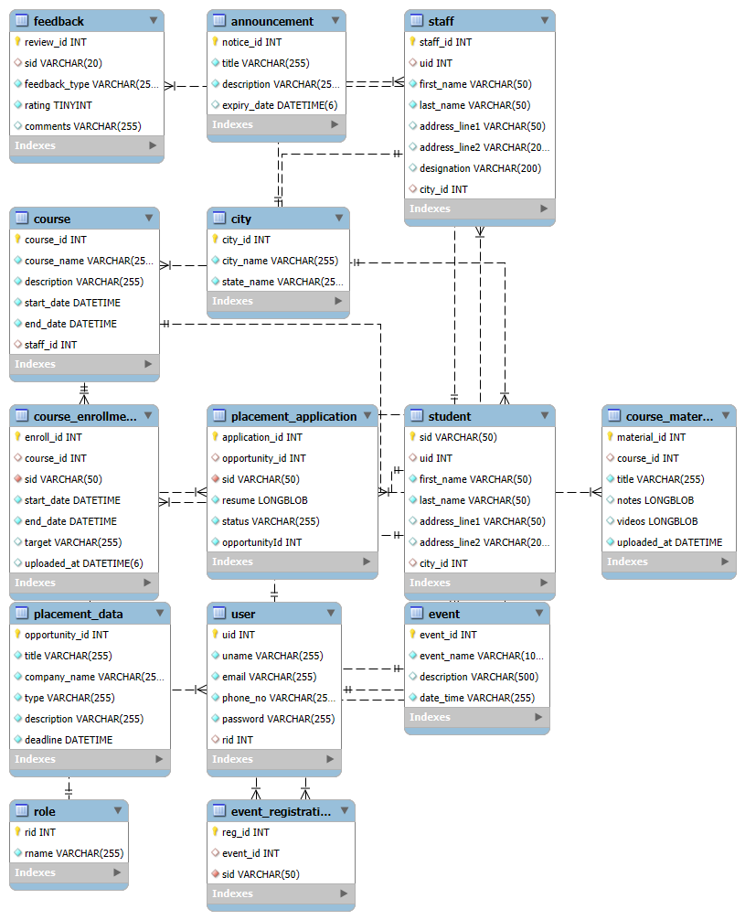

Fig. E-R diagram shows database of E-College Portal

# Snapshots:

* + **Home Page:**

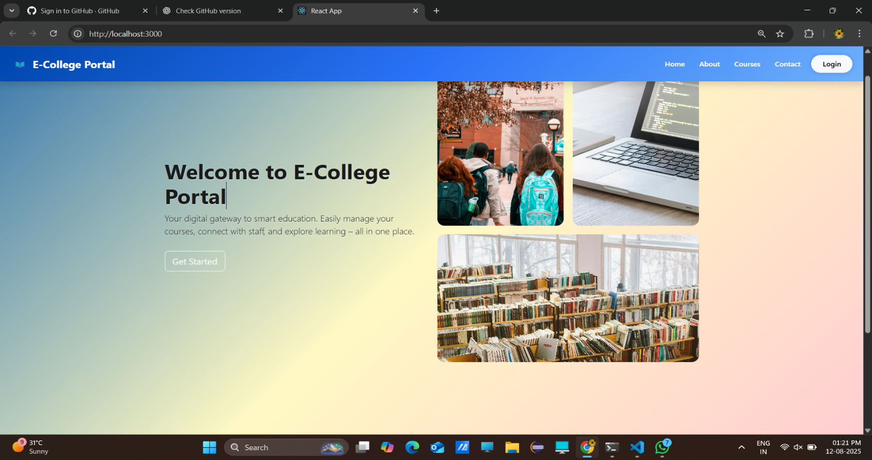

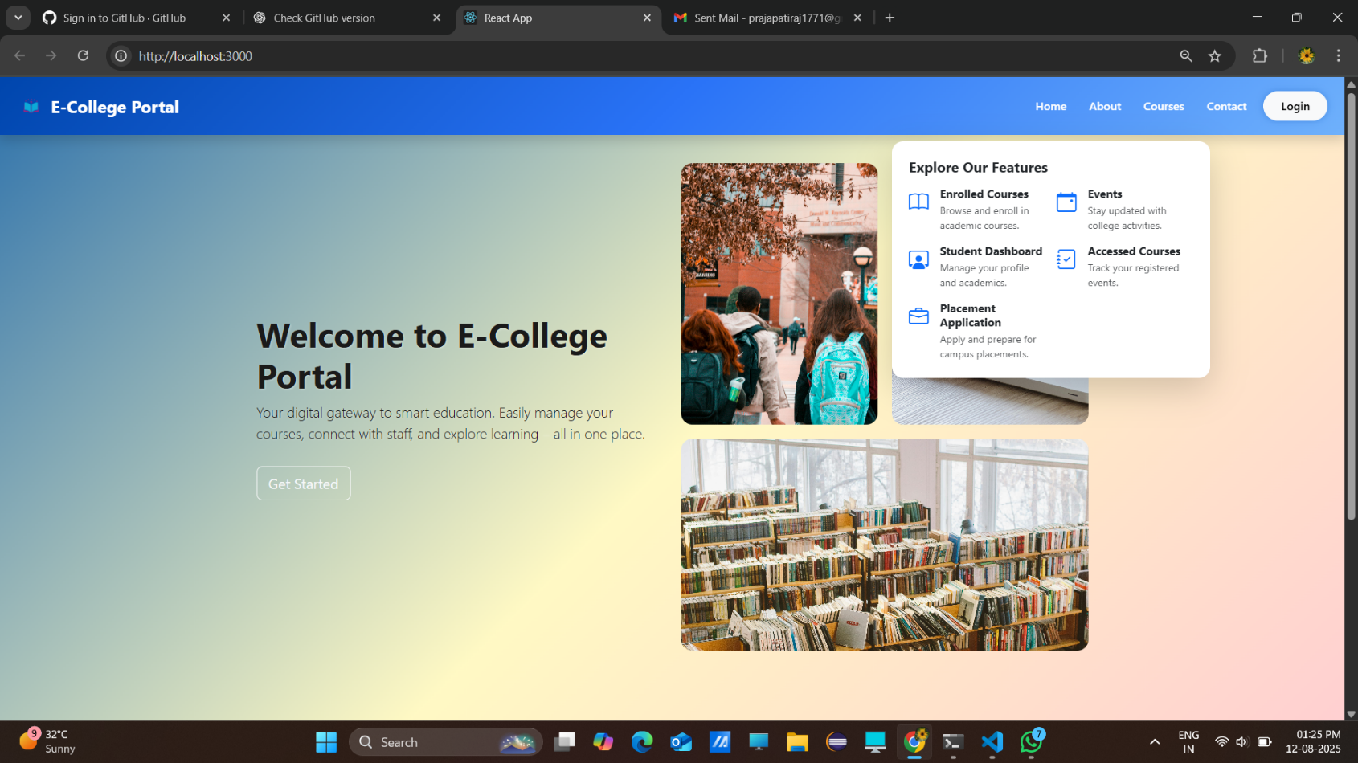

# Login Page

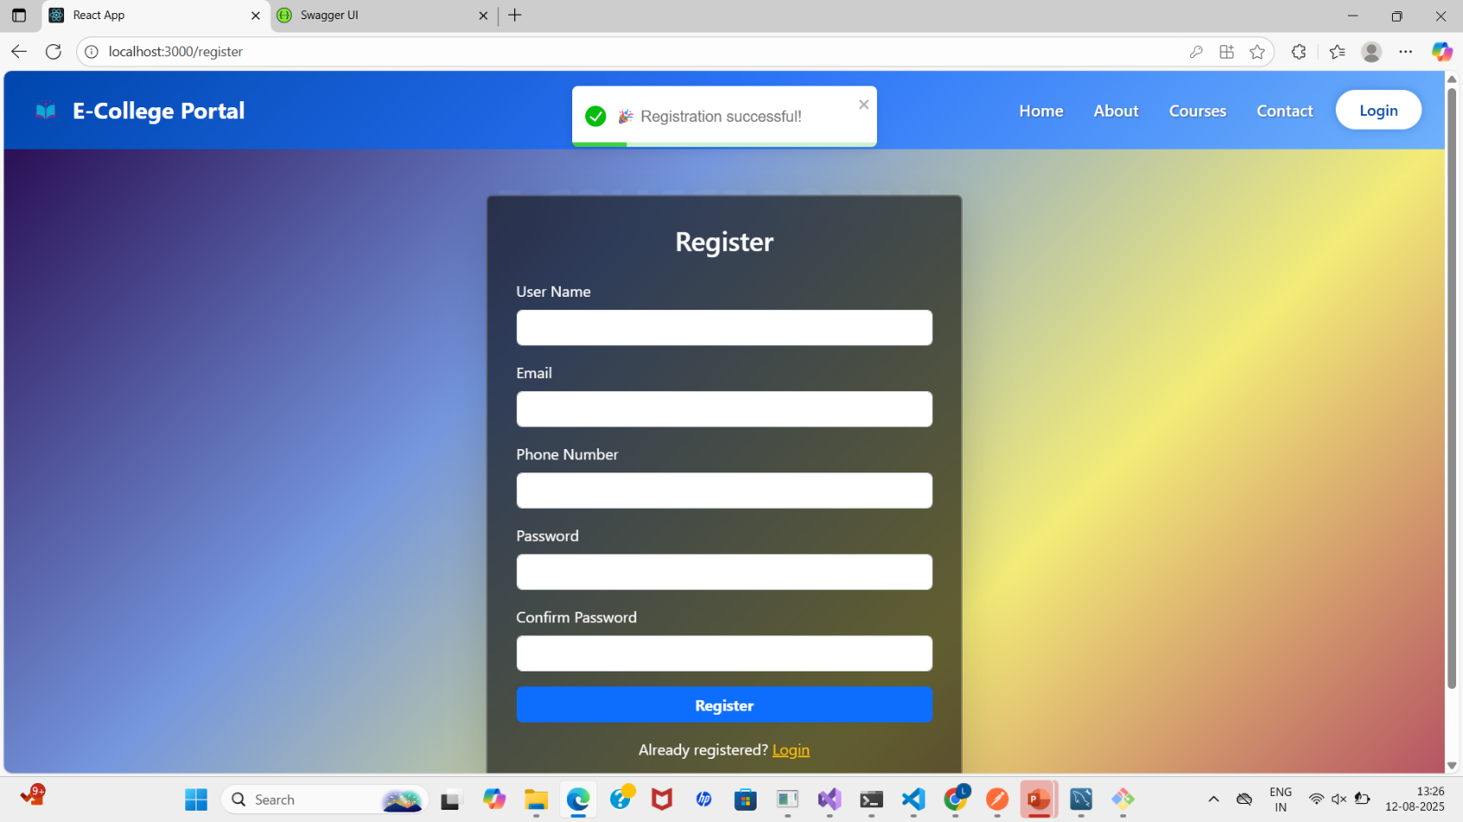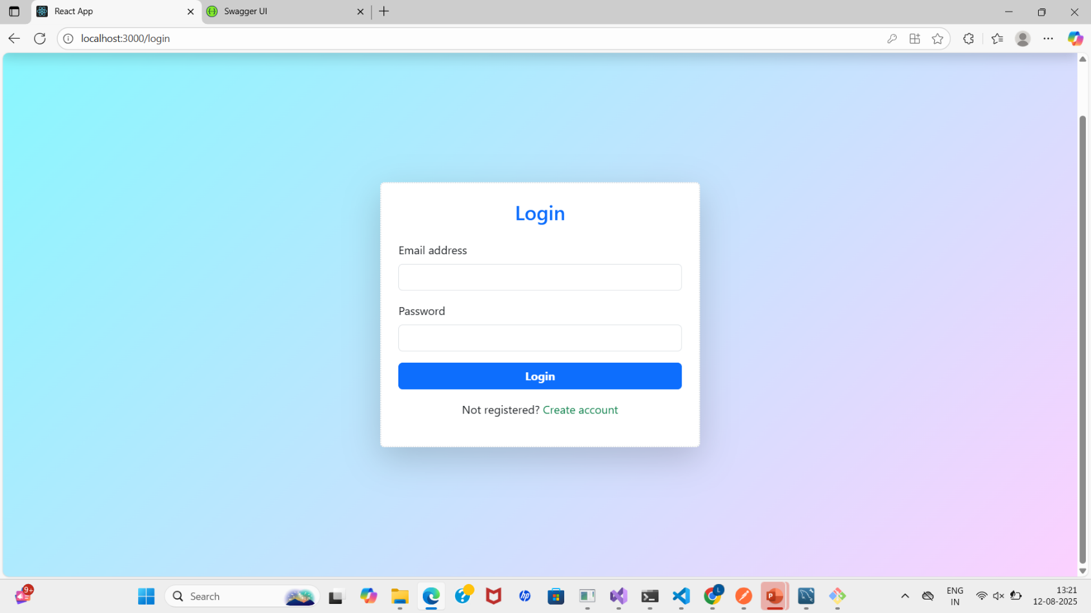

# Student Profile

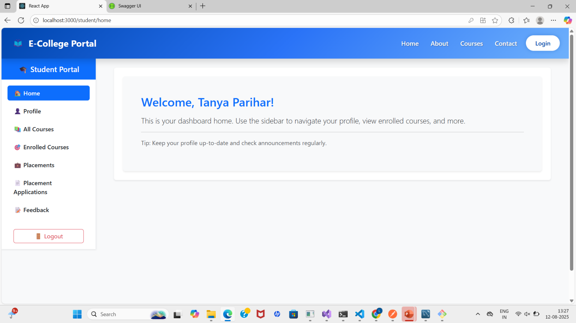

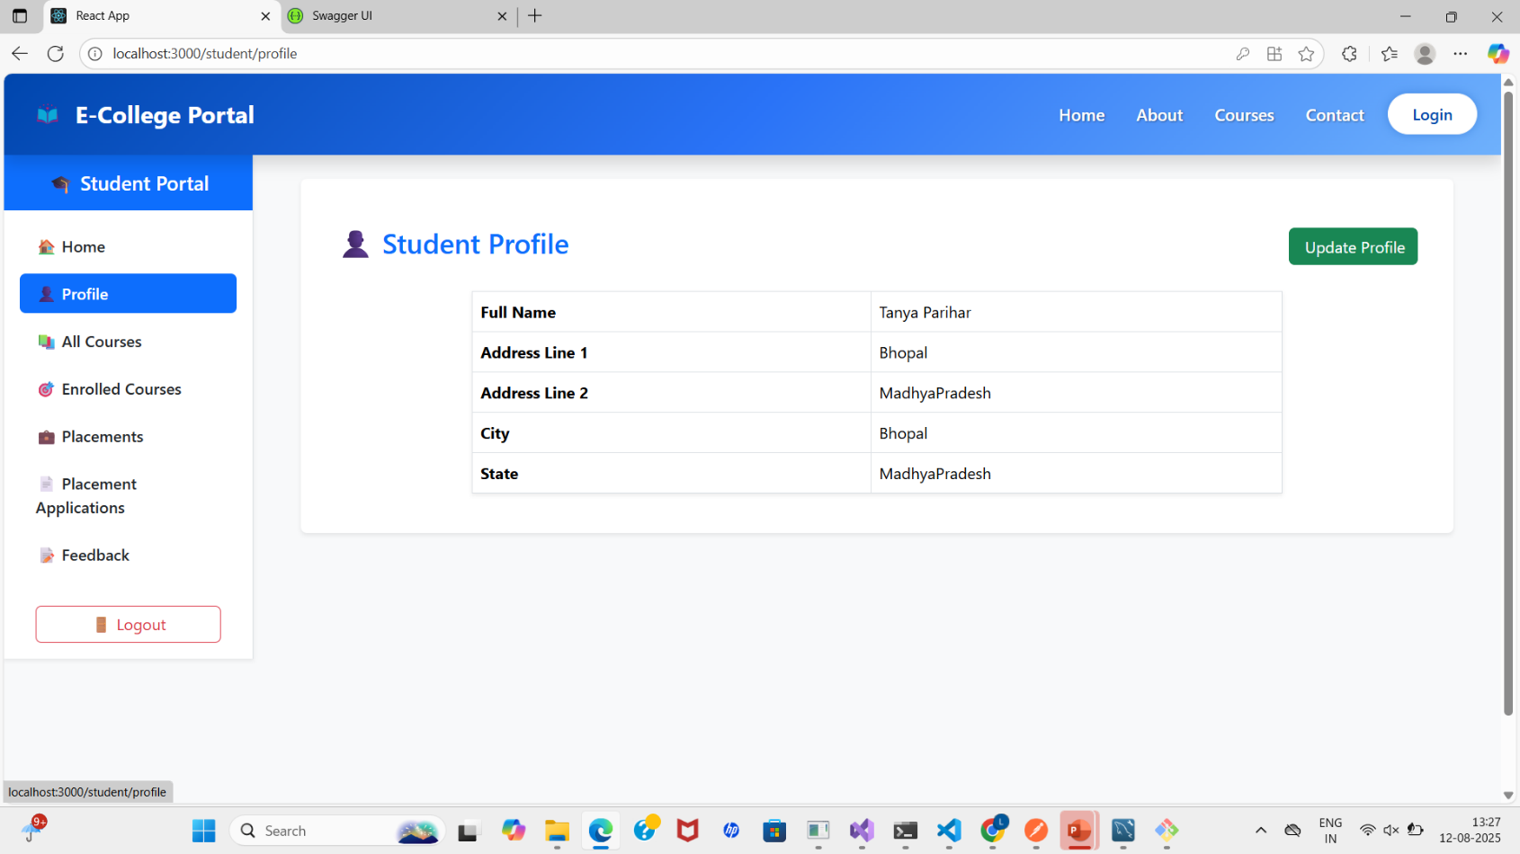

# Courses

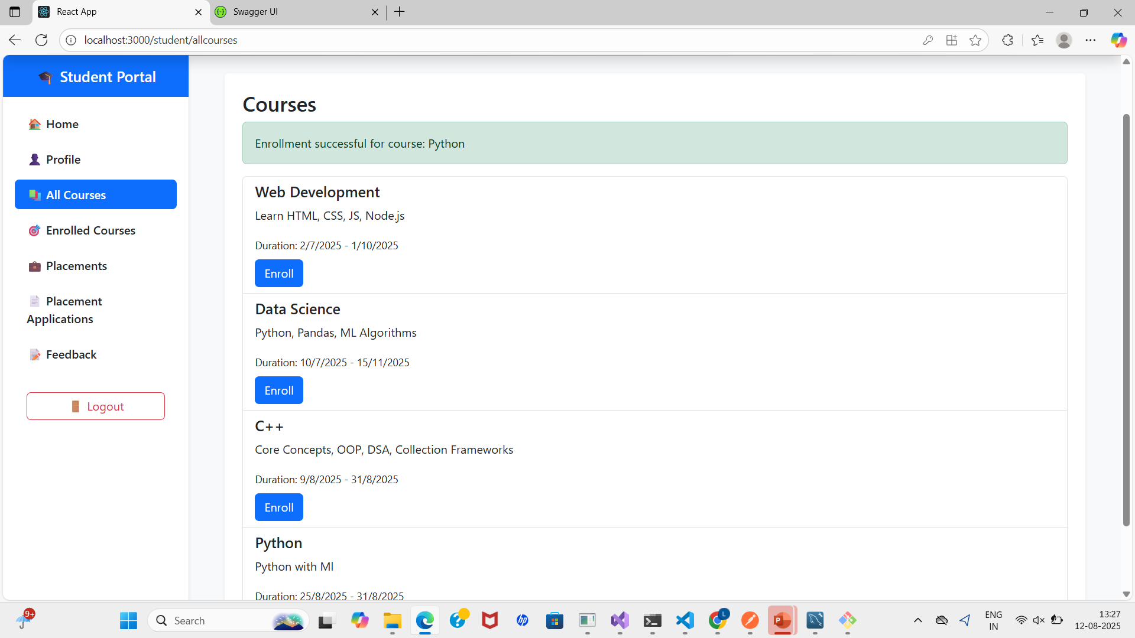

# Placement Opportunities

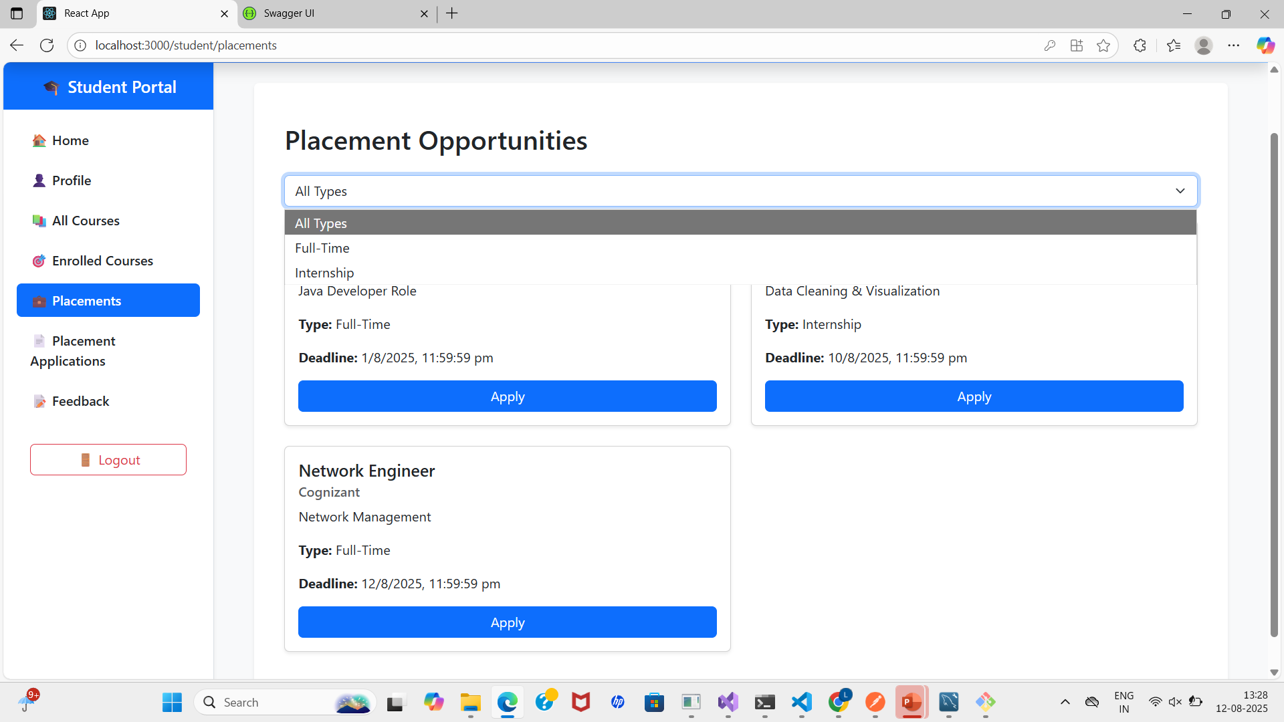

# Staff Dashboard

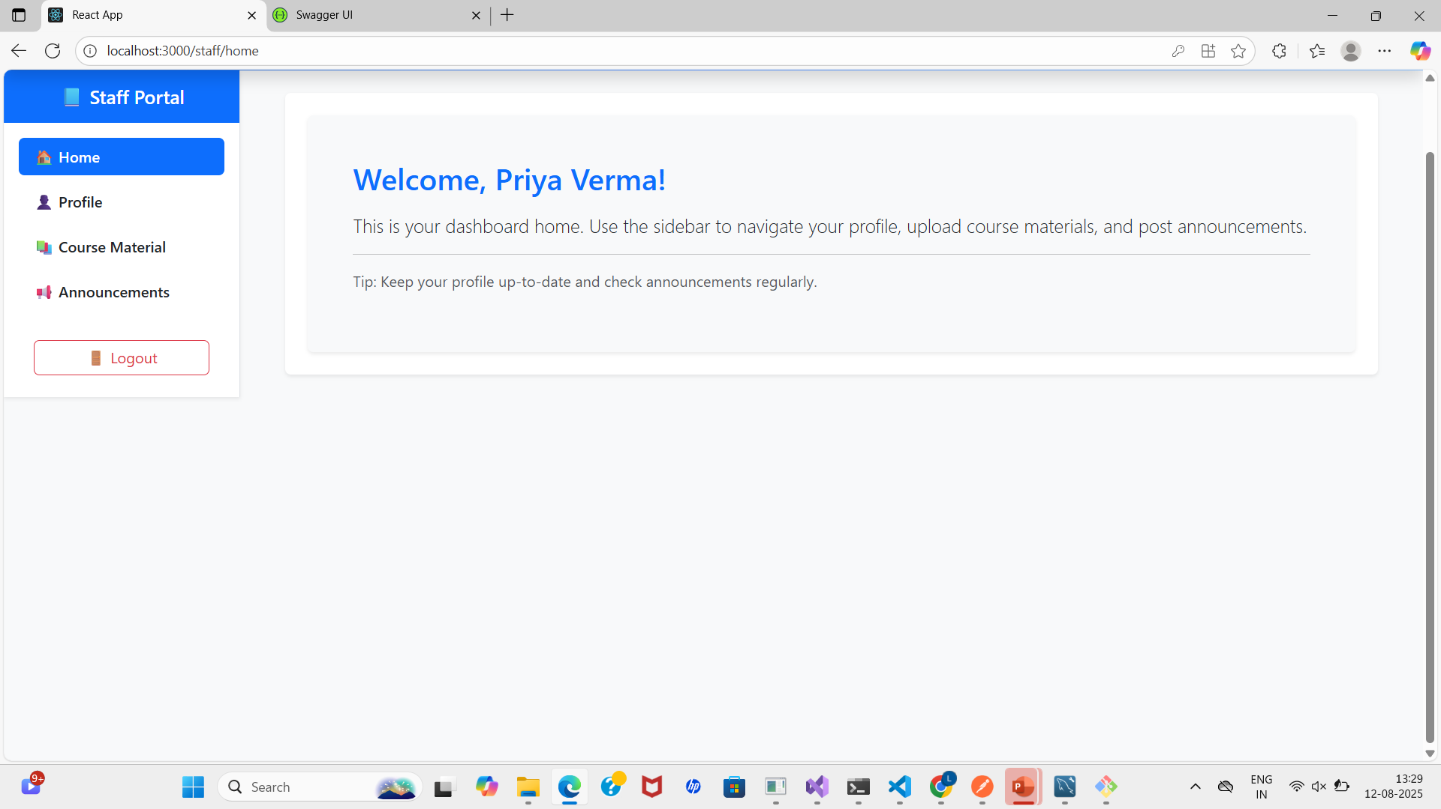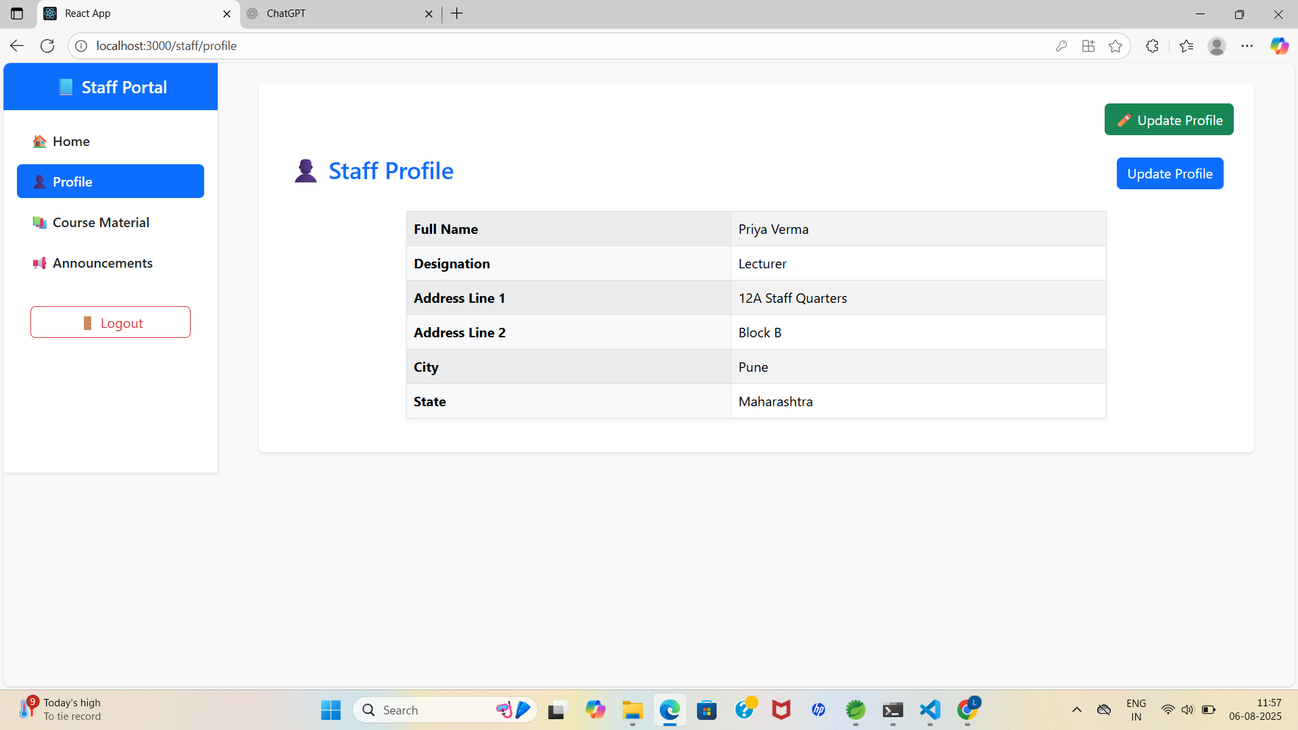

# Admin Dashboard

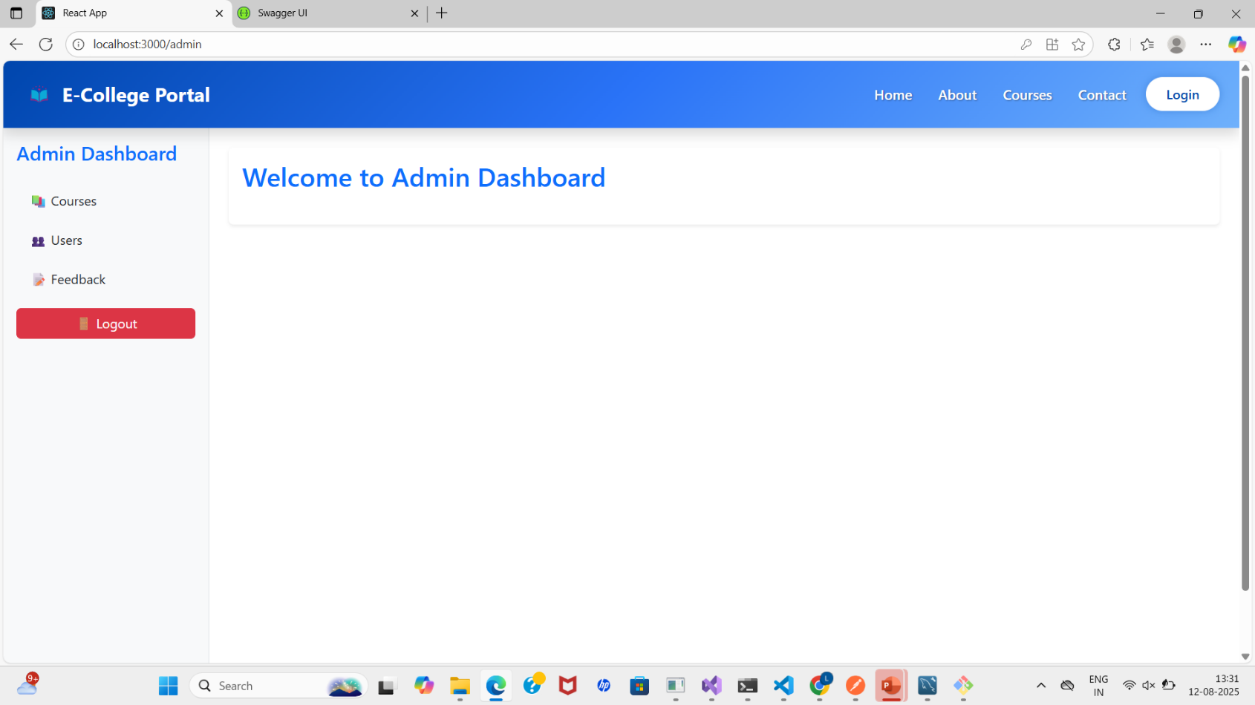

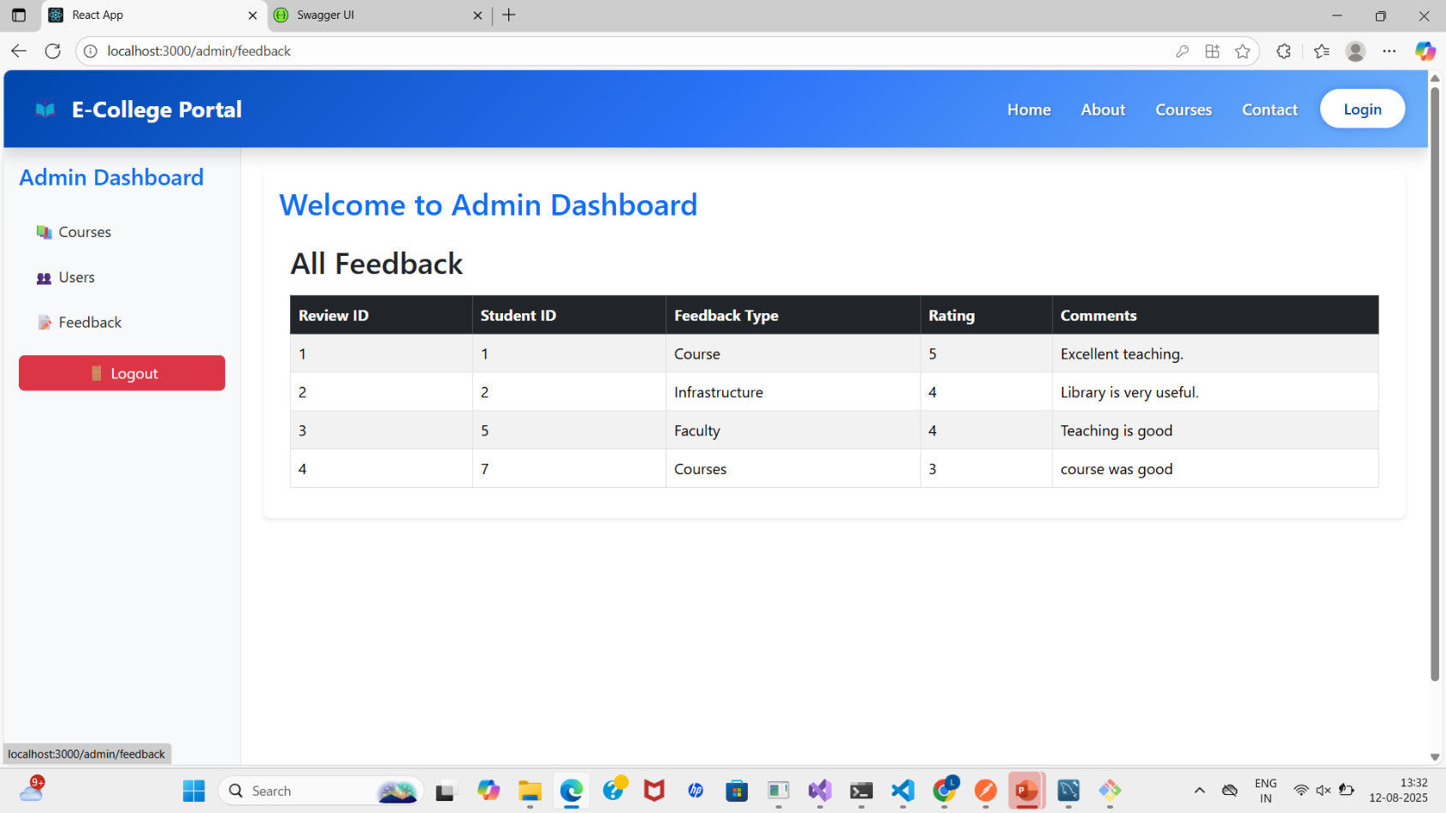

# CONCLUSION AND FUTURE SCOPE

The E-College Portal provides a comprehensive and efficient digital platform to streamline academic and administrative processes within a college environment.  
It offers an easy-to-use interface for students, staff, and administrators, enabling tasks such as profile management, course registration, content access, internship applications, event participation, and feedback submission — all in one place.

By integrating multiple functionalities into a single system, the portal reduces manual work, improves communication, and enhances the overall user experience. It bridges the gap between students and administration, ensuring transparent, quick, and reliable access to information and services.

In the future, the portal can be expanded to:

* Implement advanced analytics for tracking student performance and engagement.
* Provide AI-powered recommendations for courses, internships, and events.
* Integrate SMS/email/app notifications for important updates.
* Enable online fee payment and financial tracking.
* Offer multilingual support to cater to diverse user groups.
* Scale the system for inter-college collaborations and national-level access.

With continuous development and adoption, the E-College Portal has the potential to become a one-stop digital hub for all academic, administrative, and student engagement activities.